Chapter 15

Exercise Solutions

Ex 15.1
- 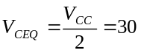V
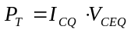
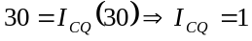A
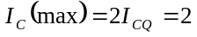A
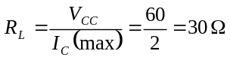
- 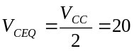V
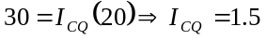A
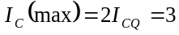A
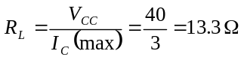
- 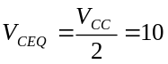V
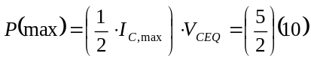
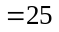W
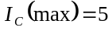A
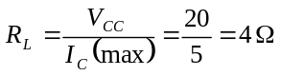
_______________________________________

Ex 15.2
- 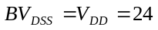V
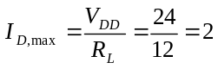A
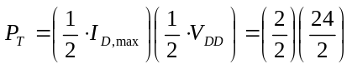
W
- 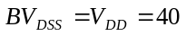V
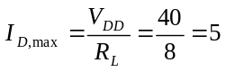A
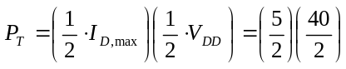
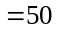W
_______________________________________

Test Your Understanding Solutions

TYU 15.1
- Collector Region,
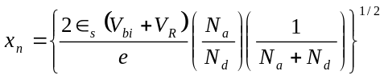
Neglecting 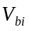,
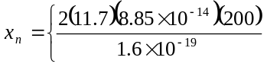
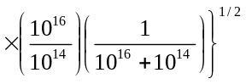
or 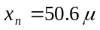m
- Base Region,
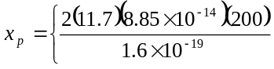
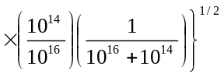
or 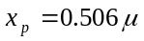m
_______________________________________

TYU 15.2
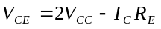
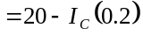
So
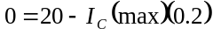
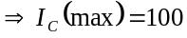mA
Maximum power at the center of the load line
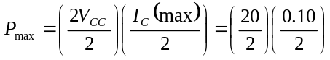
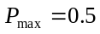W
_______________________________________

